NOTES ON THE 153-DEGREE MAGNET:
ENERGY MEASUREMENTS AND THE 153CALC PROGRAM
J. Ball July 2007

I. Magnet Properties
Bend angle: 153 degrees
Bend radius: 72 inches
Field Index: n = ½
Focal lengths: image = object = 72 inches
Magnification: 1.0

II. Energy Dispersion and Measurement Accuracy
The general equation for the dispersion of a bending magnet is,

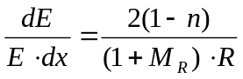 (1)
Inserting the relevant parameters for the 153-deg magnet, we get,

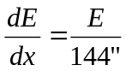 (2)
If we are interested in measuring the energy of a proton beam of about 50 MeV, then the dispersion of this beam from the above equation will be about 0.35 MeV/inch. This means that if we have an uncertainty in the positioning of the entrance or exit slits of the order of 0.1 inch, then the uncertainty in the beam energy will be 35 keV.
Alternatively, if we want to make sure we know the energy to better than 0.1 MeV, then we must know the slit positions to a combined uncertainty of less than 0.3 inches.

III. The B-I Relationship of the 153-degree Magnet
It is often useful to know approximately where to set the magnet current before starting an energy measurement. To get a rough idea of the magnetic field setting, we can use the approximate (non-relativistic) formula:
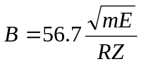 (3)
and by setting R=72, we then have,
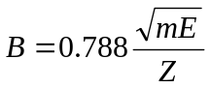 (4)
where m and Z are the mass (in amu, or mass #) and charge, of our particle and E (in MeV) is our best guess at the energy. B will be in kilogauss.
To translate our desired field B into the current needed from the 153 magnet power supply, we need to know the relationship between current and field for this magnet.
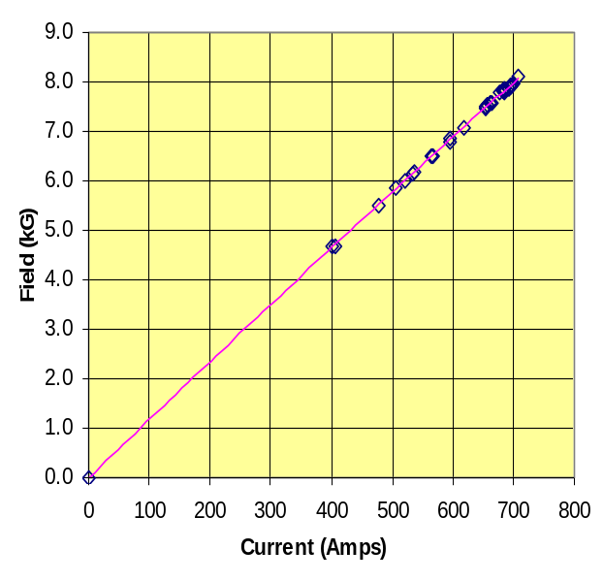
The B-I curve for the 153-degree magnet is shown at the right. The data for this plot were taken from old run sheets, from the coupled operation days, when we often measured the particle energy before an experiment. While currents needed to produce a desired field could be estimated from this graph, a good approximation to this B-I relationship is:
I = 87·B (5)
As an example, if we set up to accelerate 51 MeV protons, then from equation (2) we see that the field required from the 153-degree magnet will be ~5.63 kG. Using equation (5) we find that 490 amps will be a good place to start the magnet for determining the actual energy of the extracted beam.

IV. Measuring the Field Setting of the 153-degree Magnet
After the magnet has been adjusted to the current necessary to transmit the extracted beam, the field is determined from the NMR unit located in the instrument panel in the ORIC control room.
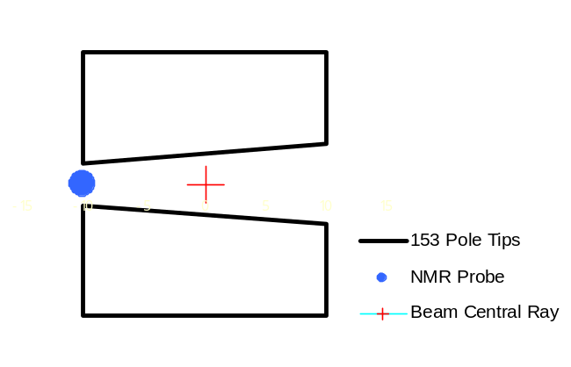
Note, however, that the field read by the NMR unit will not be the field that the beam sees in traveling through the magnet. Remember that this is an n = ½ magnet, which means that the field falls off as a function of radius. This is accomplished by properly tapering the pole tips as indicated in the sketch at the right. In this sketch, the amount of tapering has been exaggerated. One problem of such a field is that there is no flat area in which to locate the NMR probe. Instead, the probe is located as indicated by the blue dot in the region where the field “rolls over” and creates a small region of fairly uniform field. While not ideal, it is sufficiently uniform to provide a reasonable signal from the NMR unit.
Since the field at the location of the NMR unit is larger than the 72-inch radius where the central ray of the beam passes, the measured field will need to be corrected for this difference. From calibration experiments done in the mid 1960’s, this relationship is:
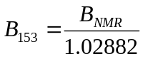 (6)
V. Beam Energy from the 153-degree Magnet Field
Once the corrected magnet field has been determined from equation (6), the energy of the beam is given by the equation:
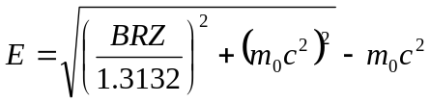 (7)
Where B is the 153-degree magnet field in kilogauss, R is the magnet radius in inches, Z is the charge on the particle and m₀c² is the rest mass of the particle in MeV.
Here we have used the complete relativistic form of the equation. For our rough estimates, like equation (3), we used the simple non-relativistic equations, but for the final determination of the particle energies we need to use the relativistically correct formula of equation (7).
For reference, the value of m₀c² for protons is 938.255 MeV, for deuterons 1875.58 MeV, for alpha particles 3727.31 MeV, etc.
To avoid having to perform this calculation by hand, a small Windows program has been written to provide this function. This program is described in the following section.

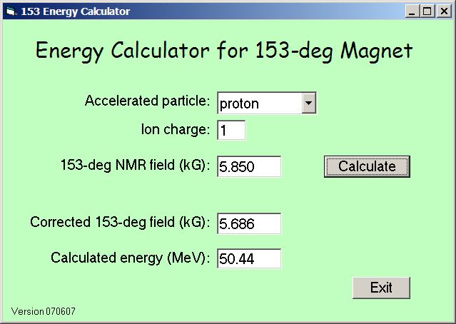
VI. The 153Calc Program
A screen shot of this program is shown at the right.
To use this program, first use the pull-down list to select a particle, then input the field read from the NMR unit. Clicking the “Calculate” button then provides the particle energy. The corrected 153-degree field is also shown for reference.
This program is included on the ORIC Programs disk in the Other Programs folder.
For particles with Z greater than 1, the ion charge may be changed if desired. If a non-physical value is selected, the box turns red and no calculation can be made. If the ion charge is physically allowed but less than fully stripped, the box will turn yellow as a reminder, but the calculation can proceed.
The calculation made by this program assumes that R=72.0 inches and that the conversion factor for the NMR field is 1.02882. If these values should need to be changed in the future, this can be easily accomplished by using a 153Calc.int file. This is a text file with only one line of 3 entries. They are, in order, the value of R, the value of the NMR constant, and a version identifier. The identifier is treated as a string constant and will be output after “Version” in the lower left of the window. An example file is included on the program disk. If this file is not present, the program uses the above default values.

